**Document on the post-processed data of Tianwen-1 Mars Energetic Particles Analyzer（MEPA）**

Rev. 1.0

Feb 27, 2024

Prepared by

Yiqun Yu, Longhui Liu

This document describes the post-processed data of the Mars Energetic Particles Analyzer（MEPA）level 2B datasets from Tianwen-1 downloaded from the Lunar and Planetary Data Release System at National Astronomical Observatories of China

(https://moon.bao.ac.cn/web/zhmanager/mars1)

The level 2B data involves quantity of parameters including UTC-time, Heavy-Ion_Events_Count, Heavy-Ion_Fake_Events_Count, Heavy-Ion_Science_Data, e/p/he_Events_Count, e/p/he_Fake_Events_Count, e/p/he_Science_Data, Divide_Ratio, VA_Temperature, CSI2_Temperature, SI2_Temperature, PSDH_Temperature, Total_Trigger_Count, e/p/he_Trigger_Count, Heavy-ion_Trigger_Count, Penetration_Count, Longitude， Latitude, Altitude, Instrument_Observation_Direction_X/Y/Z, Solar_Incident_Angle, Solar_Azimuth_Angle and X/Y/Z-axis_Position_J2000.

The differential flux is derived using e/p/he_Events_Count, e/p/he_Trigger_Count and e/p/he_Science_Data as detailed in Section I. However, the downloaded level 2B data includes a significant number of incidences beyond the instuments’ filed of view, leading to unaccounted diffusion events. We processed the data by applying a theoretical model of particle distribution to discern the actual vs. diffusion event proportions, and employing statistical methods for random sampling and elimination based on the diffusion event ratio. The methodology and result are shown in Section II.

The data we have processd is consistent with the instrument simulation results of Tang et al., 2020, but in the practical application of proton flux, high-precision differential flux and integral flux may cause significant errors due to statistical methods (such as extremely large or small proton flux at a certain time). When the data is taken with lower time accuracy, the size of integral flux will reduce due to the average of the data, but this will be more in line with the actual distribution of proton flux. The differential flux distribution of alpha particles in the processed results resembles noise, possibly due to high-energy alpha particles within this energy spectrum, a scenario that remains under-explored, so the data of alpha particles should be used with caution. The electronic data was not processed due to difficulties in discerning diffusion events.

I. Principle of flux calculation

A detector located in an isotropic particle radiation field, whose detected particle count rate N is proportional to the particle flux J,

The proportional coefficient G called the geometric factor and can be expressed by the following formula:

We calculate the sampling ratio by dividing e/p/he_Events_Count by e/p/he_Trigger_Count , and differentiate the particle types using the particle energy data in e/p/he_Science_Data to obtain the index of different particles. After completing the elimination of diffusion events, we obtain the Proton/He_Index. Then we count the particle counts (obtaining the value of N) using the on-orbit particle identification criteria (as shown in Table 1) and calculate the differential flux (the value of J) of the particles using geometric factors (the value of G, as shown in Table 2). Calculated as follows:

**Table 1: On-orbit particle identification criteria**

|  |  |
| --- | --- |
| Particle Type | PID criteria (ΔE, E andΔE1 all in unit of MeV) |
| Electron |  |
| Proton |  |
| Helium |  |
| Heavy ion |  |

**Table 2: Geometric factors of energy channels for electrons, protons, and alpha particles**

|  |  |  |  |  |  |  |
| --- | --- | --- | --- | --- | --- | --- |
| **Energy channel serial number** | **Electron** | | **Proton** | | **Alpha particle** | |
| **Energy channel division**  **( MeV )** | **Electron**  **_Geom**  **( cm2sr )** | **Energy channel division**  **( MeV )** | **Proton**  **_Geom**  **( cm2sr )** | **Energy channel division**  **( MeV )** | **He**  **_Geom**  **( cm2sr )** |
| 1 | [0.1,0.13) | 0.08 | [2, 2.6) | 0.20 | [25, 29.2) | 0.21 |
| 2 | [0.13,0.18) | 0.11 | [2.6, 3.3) | 0.21 | [29.2, 34.1) | 0.22 |
| 3 | [0.18, 0.25) | 0.16 | [3.3, 4.2) | 0.20 | [34.1, 39.8) | 0.21 |
| 4 | [0.25, 0.33) | 0.19 | [4.2, 5.3) | 0.21 | [39.8, 46.5) | 0.21 |
| 5 | [0.33, 0.45) | 0.21 | [5.3, 6.8) | 0.20 | [46.5, 54.3) | 0.22 |
| 6 | [0.45, 0.60) | 0.23 | [6.8, 8.7) | 0.21 | [54.3, 63.5) | 0.24 |
| 7 | [0.60, 0.81) | 0.23 | [8.7, 11.1) | 0.22 | [63.5, 74.1) | 0.24 |
| 8 | [0.81, 1.10) | 0.25 | [11.1, 14.1) | 0.22 | [74.1, 86.6) | 0.26 |
| 9 | [1.10, 1.48) | 0.27 | [14.1, 18.1) | 0.24 | [86.6, 101.2) | 0.29 |
| 10 | [1.48, 1.99) | 0.30 | [18.1, 23.1) | 0.26 | [101.2, 118.1) | 0.32 |
| 11 | [1.99, 2.69) | 0.36 | [23.1, 29.4) | 0.33 | [118.1, 138) | 0.39 |
| 12 | [2.69, 3.63) | 0.52 | [29.4, 37.6) | 0.42 | [138., 161.2) | 0.51 |
| 13 | [3.63, 4.89) | 0.77 | [37.6, 48.0) | 0.79 | [161.2, 188.3) | 0.86 |
| 14 | [4.89, 6.60) | 0.96 | [48.0, 61.3) | 1.23 | [188.3, 219.9) | 1.16 |
| 15 | [6.60, 8.90) | 1.07 | [61.3, 78.3) | 1.44 | [219.9, 256.8) | 1.39 |
| 16 | [8.90, 12) | 1.20 | [78.3, 100) | 1.58 | [256.8, 300) | 1.50 |

**II. Introduction to processed data**

We processed the data based on some methods and suggestions provided by the payload development team as shown in Figure 1. As we mentioned earlier, there are diffusion events outside the field of view in particle data, and the distribution of these diffusion particles is scattered in the ΔE-E two-dimensional spectrum of the ΔE-E telescope. We first removed most of the diffusion particles that were not mixed in the feature bands using the envelope method. Then, based on the Gaussian distribution of the effective data particles in the ‘counts-log(E*ΔE)’ graph, the actual particle distribution was fitted with ‘Gaussian distribution+diffusion event distribution’. Then, based on the proportion of diffusion events, the particles at each recording time are statistically randomly removed, and the final result is consistent with the theoretical and simulation results of the instrument.

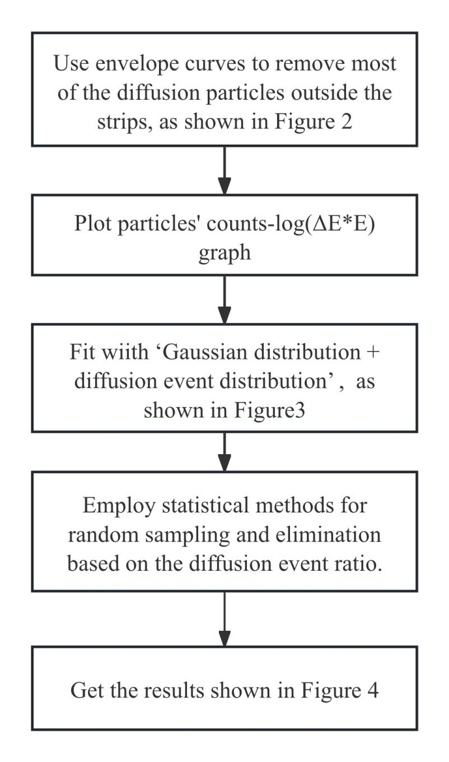

*Figure 1: Data processing flow*

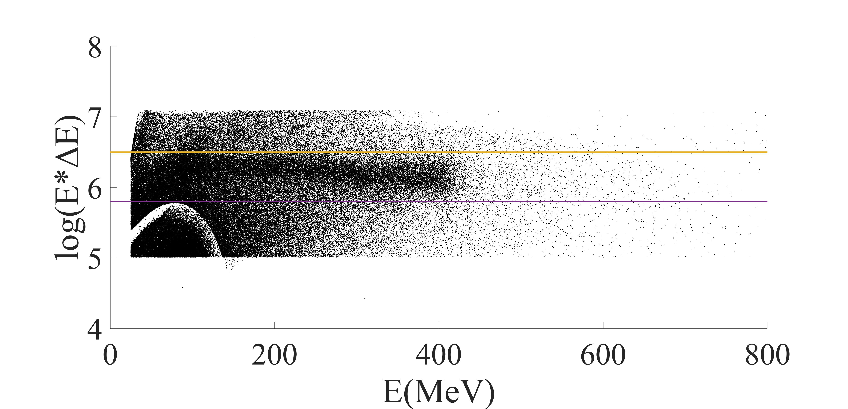

*Figure 2: Envelope processed particle log(E*ΔE)-E two-dimensional spectrum*

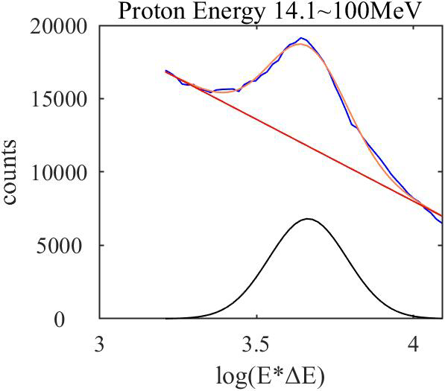

*Figure 3: Proton fitting results with energy channels from 14.1 to 100MeV. The vertical axis of the image is the number of particles, the horizontal axis is log(E*ΔE), the purple broken line is the actual distribution of particles, the orange curve is the fitted distribution of particles, the black curve is the effective particle distribution, and the red curve is the diffusion particle distribution*



*Figure 4: The ΔE-E two-dimensional spectrum of the particle fitting results, in which the black part is the diffusion event and the blue part is the actual effective particles obtained by processing*

The new post-processed data are all saved in files named HP_xxx_x_xxxxxxxxxxxxxx_xxxxxxxxxx_xxxxx.txt (the file name retains the downloaded 2B level data file name, except for the instrument name). Here is an example of a file name (as shown in Figure 5). The meaning of the file name is as follows:



*Figure 5: A stored file name*

digit 1-2: HP, the processed 2B level data is a dataset containing heavy ion data

digit 4-6: SCI, science data

digit 8: N, including real-time data (data collected directly downstream) and playback data (data stored by the detector and delayed for playback).

digit 10-13: year of the first data

digit 14-15: month of the first data

digit 16-17: day of the first data

digit 18-19: hour of the first data

digit 20-21: minute of the first data

digit 22-23: second of the first data

digit 25-28: year of the end data

digit 29-30: month of the end data

digit 31-32: day of the end data

digit 33-34: hour of the end data

digit 35-36: minute of the end data

digit 37-38: second of the end data

digit 40-44: detection cycle number

**Table 3: Post-processed data file structure**

|  |  |  |  |
| --- | --- | --- | --- |
| **Field Name** | **Field_**  **number** | **Bytes** | **Description** |
| Time | 1 | 14 | Coordinated universal time with four-second cadence. |
| Epoch_Time | 2 | 14 | The epoch time format for the IRF package with four-second cadence. |
| Longitude | 3 | 12 | Spacecraft longitude (maybe a nan value). |
| Latitude | 4 | 12 | Spacecraft latitude (maybe a nan value). |
| Altitude | 5 | 12 | Spacecraft altitude (maybe a nan value). |
| X_J2000 | 6 | 17 | J2000 Coordinate System. |
| Y_J2000 | 7 | 17 | J2000 Coordinate System. |
| Z_J2000 | 8 | 17 | J2000 Coordinate System. |
| X_MSO | 9 | 16 | MSO Coordinate System. |
| Y_MSO | 10 | 16 | MSO Coordinate System. |
| Z_MSO | 11 | 16 | MSO Coordinate System. |
| Instrument_Observation_Direction_X | 12 | 12 | Incidence vector of the symmetry axis of the sensor FOV in J2000 Coordinate System. |
| Instrument_Observation_Direction_Y | 13 | 12 | Incidence vector of the symmetry axis of the sensor FOV in J2000 Coordinate System. |
| Instrument_Observation_Direction_Z | 14 | 12 | Incidence vector of the symmetry axis of the sensor FOV in J2000 Coordinate System. |
| Solar_Incident_Angle | 15 | 6 | Solar incident angle. |
| Solar_Azimuth_Angle | 16 | 6 | Solar azimuth angle. |
| Energy_CSI_1～Energy_CSI_22 | 17~38 | 7 | The particle energy value detected by the CsI detector (third detector) that is separately distinguished from the original data. Due to the fact that each data packet records 22 events when the detector records particle events, the data is divided into 22 variables for recording, with an energy value format of m * 22 and "m" representing the number of time counts (the same applies to other data recorded as 22 variables thereafter). |
| Energy_SD1_1～Energy_SD1_22 | 39～60 | 7 | The particle energy value detected by the SD1 detector (first detector) that is separately distinguished from the original data. |
| Energy_SD2_1～Energy_SD2_22 | 61～82 | 7 | The particle energy value detected by the SD2 detector (second detector) that is separately distinguished from the original data. |
| Energy_Total_1～Energy_Total_22 | 83～104 | 7 | The sum of event energies detected by three detectors. |
| He_Index_1～He_Index_22 | 105～126 | 1 | The alpha particle index is obtained by distinguishing particle types based on the energy relationship detected by each detector. A value of 1 corresponds to the energy value of the alpha particle, and a value of 0 represents other particles **(the diffuse event data has been removed)**. |
| Electron_Index_1～Electron_Index_22 | 127～148 | 1 | The electron index obtained by distinguishing particle types based on the energy relationship detected by each detector, where a value of 1 corresponds to the energy value of the electron, and a value of 0 represents other particles (the diffuse event data was not excluded). |
| Proton_Index_1～Proton_Index_22 | 149～170 | 1 | The proton index obtained by distinguishing particle types based on the energy relationship detected by each detector, with a value of 1 corresponding to the energy value of the proton, and a value of 0 indicating other particles **(the diffuse event data has been removed)**. |
| He_Sample_Counts_1~He_Sample_Counts_22 | 171～192 | 2 | The value of alpha particle event count (the diffuse event data was not excluded). |
| Electron_Sample_Counts_1～Electron_Sample_Counts_22 | 193～214 | 2 | The value of electron event count (the diffuse event data was not excluded). |
| Proton_Sample_Counts_1～Proton_Sample_Counts_22 | 215～236 | 2 | The value of proton event count (the diffuse event data was not excluded). |
| He_Flux_1～He_Flux_22 | 237～258 | 16 | Calculated alpha particle flux **(the diffuse event data has been removed)**. But the reliability of the results needs to be verified |
| Electron_Flux_1～Electron_Flux_22 | 259～280 | 16 | Calculated electron flux (the diffuse event data was not excluded). |
| Proton_Flux_1～Proton_Flux_22 | 281～302 | 16 | Calculated proton flux **(the diffuse event data has been removed)**. |